Clubhouse Reservations 2023

The club is available for Members to host a private party from May 20 to August 29, 2023, pending staff and clubhouse availability . Tented events are not allowed from July 1 to Labor Day. The Club Manager or designee will be on-site for parties over 50 guests. Contact Tom Donnelly, Reservation Chair, to reserve the Club for a private party at (703) 893-6369 or tdonnelly1947@gmail.com.

Your Club is a private, not-for-profit corporation. To protect its status, the Board of Directors asks for your cooperation in adhering to the following rules for private social affairs.

- The Club is for use of the Members and their guests only. Only Members may reserve the clubhouse for personal use after regular hours, beginning at 6:00 p.m. The bar will be closed and music must cease by 10:30 p.m. All guests must leave the premises by 11:00 p.m.

- A member may not reserve the clubhouse for use by an outside co-host, individual, or group. A member engaging the clubhouse may do so only for personal use of his/her family and friends and must attend the affair with personal financial responsibility. Members are not allowed to reserve the club house on behalf or for the benefit of an organization to which they may belong or support. If there are any questions about this restriction, contact the Reservation Chair.

- No fee, collection, or other reimbursement shall be charged or paid by a guest to a private event.

- Parties for teenagers must have adult supervision at all times.

- Use of alcoholic beverages is subject to all local and State of Delaware rules and regulations. Alcoholic beverages may not be served to anyone under 21 years of age. The Member-host is responsible for ensuring compliance with all rules and regulations governing service and consumption of alcohol.

- The Member-host must reimburse the Club for any damage to the clubhouse, furniture, fixtures, or equipment by anyone in attendance.

- The Member-host must attend and remain at the party for the duration of the event.

- Club supplies are not available for private parties.

- Excessively loud music will disturb the neighbors and is not permitted.

- Furniture and equipment arrangements are the responsibility of the Member-host. Please contact the Club Manager at least two weeks in advance of the party to discuss your plans for entertainment, decorations and special equipment. The club house will be open to members during normal hours; however, full access to facilities may be limited prior to closing.

- Set-up will be restricted as follows:

PARTY SET-UP: Same day only after 2 p.m.
TENT SET-UP: Arrange with Manager.

- The Member-host is responsible to see that caterers leave the kitchen clean and in order and abide by the rules of the kitchen. In addition, the entire facility, building and grounds must be returned to their original condition in terms of cleanliness and arrangement of furniture no later than 11:30 p.m. the night of the party.

- The Member may arrange through the Club Manager for the Club’s cleaning service to clean the facility after the private event for a $250 fee.

- If the Member-host violates any of the rules governing use of the clubhouse for private parties, the Member will receive a warning. Subsequent violations will lead to suspension of the Member’s eligibility to host future functions for one year.

- CHARGES: The Club fee and refundable damage deposit, payable to HABC, must accompany the Reservation Application. For events of over 50 guests, please include the manager’s fee and submit evidence of an insurance rider naming the HABC as the indemnified in an amount not less than $1,000,000. (Staff gratuities for a private event are appreciated and are at your discretion).

Private Party Fee Schedule 2023

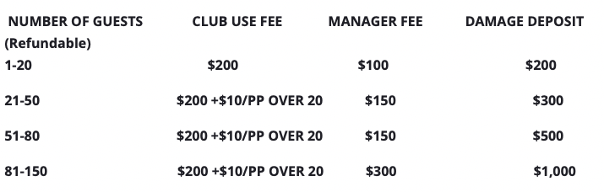
Note: *For events of 50 guests or less, no staff will be present.
The Member is responsible for set-up and clean-up and must
return the club house and deck to their original condition.

